From: https://davidstockmanscontracorner.com/not-repo-madness-its-the-deficit-stupid/

Not Repo Madness: It's The Deficit, Stupid!
By David Stockman. Posted On Friday, September 27th, 2019
If you want to know how much Keynesian central banking has corrupted America's fiscal governance---just consider all the risible nonsense being issued by Wall Street with respect to the repo ruction now roiling its bullish equipoise.
Bankers, for instance, has been quick to blame the far more stringent regulations regarding liquidity requirements---as if the near collapse of an over-leveraged and illiquid banking system in the fall of 2008 never happened.
Likewise, the permabulls want to flood the casino with newly minted cash---just in case there is some threat to rising stock averages lurking below the deck.
And the monetary policy cognoscenti are even more blatant. They insist that there is now a shortage of monetary coal in New Castle because, yes, the Fed purportedly overdid it with QT when it tepidly shrank its bloated balance sheet from $4.5 trillion to $3.8 trillion during the last two years.
Apparently, the resulting $1.35 trillion level of "excess" bank reserves is not enough excess. What the Fed really needs to do, they insist, is print new bank reserves from thin air at the same rate as nominal GDP growth.
Bloomberg had a piece this morning reviewing all of this blather, which it summed up as follows after noting that already this week the Fed has put in place $250 billion of pop-up repo windows:
Simply put, the bank wants to flood the funding market with enough cash to soak up all the securities that dealers submit and leave no doubt that the critical financial-system plumbing is in fine working order ahead of the end of the quarter.
Well, for crying out loud! What's happening is not some mysterious new fangled "plumbing" failure at all; it's the ancient law of supply and demand at work---the balance of which has been knocked into a cocked hat by Washington's fiscal incontinence and Wall Street's gluttonous thirst for carry trade gambling stakes.
As to the former, consider the fact that at the June 2019 quarter end, Uncle Sam's publicly traded debt outstanding was $16.188 trillion and on Wednesday it stood at $16.733 trillion. So during the interim 62 trading days the US Treasury has sucked a stunning $543 billion from the bond pits.
That's about $9 billion per day at a time when the Fed was still (belatedly) selling down its elephantine balance sheet by more than $1 billion per day.
So talk about flow ructions: The entire US economy generates only $80 billion of GDP per business day, but since late June Uncle Sam has been absorbing $10 billion per day from the bond pits---a figure which amounts to 12.5% of GDP.
Not surprisingly, the 23 US primary dealers have gotten constipated with Treasury securities. That happened pursuant to their obligation to buy debt from Uncle Sam in turn for the privilege of selling gobs of it to the mad money printers at the Fed at a lucrative mark-up.
As shown below, current dealer holdings are more than double the peaks reached during the Great Recession. In theory, of course, financing $200 billion to $300 billion of UST's should be no sweat for dealers led by the likes of JPMorgan, Goldman, Bank of America, etc. If need be, they could go to the bond market to shore up the funding/liability side of their balance sheets.
Then again, longer-term funding would mean higher carry costs and make for a modestly less lucrative franchise to shuffle public debt from one branch of the state (treasury) to the other (Fed). In that respect, at least the MMT (modern monetary theory) folks propose to eliminate the fiction and have the Treasury sell debt directly to the Fed, with no cut for the Wall Street middle men.
Yet, the latter explain why there has been so much repo madness down on Wall Street during the last week or so. To wit, the dealers want their cheap repo so that their lucrative franchise doing god's work (shuffling the exploding public debt) will remain, well, lucrative indeed.
After all, just suppose on an average net position of $250 billion of USTs, the dealers had to pay 400 basis points more for their repo funding or about $10 billion per year. That would compare to 2018 profits of $120 billion for just the top six dealers, and upwards of $200 billion for all of them.
That's right. Last year JPMorgan had net income of $32.5 billion, while Bank of America, Goldman, Citi, Wells Fargo and Morgan Stanley reported $28.1 billion, $10.5 billion, $18 billion, $22 billion and $8.7 billion, respectively.
To be sure, we are all for business profits---even among the too big to fail banks. But to the extent that they are subsidized by central bank supplied ultra-cheap credit, that's not the least bit kosher.
In fact, the whole brouhaha about repo rates reaching the mid- or high single digits isn't the least bit kosher, either.
What's wrong with market clearing interest rates? That is, honest signals to Washington about the true cost of carrying and shuffling its brobdingnagian debts and honest funding costs for Wall Street money shufflers and gamblers who essentially extract rents from the Fed-enabled casino by funding inflated assets with deflated carry.
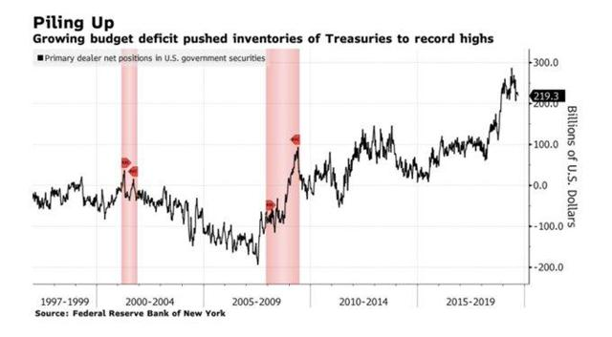
To be sure, the Fed heads claim no partiality in behalf of the obscene Wall Street profits being minted by the economically pointless carry trades they enable. Supposedly, the Fed's heavy hand on the money market interest rate is all in behalf of the greater good and prosperity of main street.
But that pretext gives the word "specious" an altogether new definition. Neither the $250 billion of pop-up repo facilities stood up this week or the $3.5 trillion of QE emitted from the Fed's printing presses between 2008 and 2015 ever really left the canyons of Wall Street.
That is, 90% of main street households were already at Peak Debt and tapped-out at the time of the financial crisis, and have added to total borrowings at a mere 0.8% annual rate since 2008. That compares to a 9.2% growth rate per annum during the housing/mortgage/credit boom between 2001 and 2008.
Likewise, the US business sector (corporate and noncorporate combined) did increase its debt rather massively, with outstandings rising from $10.1 trillion in Q4 2007 to $15.7 trillion at present or by nearly 56%. But virtually all of this gain got recycled back to Wall Street to fund financial engineering maneuvers such as stock buybacks, M&A deals and various forms of enhanced dividends and leveraged recaps.
This massive reflow back to Wall Street, of course, did prodigiously fund the inflation of risk asset prices, thereby goosing the paper wealth of the top 1% and 10% of households, which own 40% and 85% of stocks and other risk assets, respectively. But it did virtually nothing for real productive investment on main street, where real net business investment remains barely above it year 2000 level.
In a word, the cost/benefit ratio of Keynesian central banking is abysmal. It does not foster sustainable growth or wealth on main street---even as it fuels fiscal profligacy in Washington and rampant speculation on Wall Street.
Needless to say, the $545 billion taken down by the US Treasury during the last 62 trading days is only the tip of the Debtberg. The real damage resulting from the feckless interest rate repression evident in the Fed's current desperate effort to quash repo madness has been accumulating for years, and on the fiscal side has taken on the dynamics of a veritable doomsday machine.
That is to say, what is supposed to happen as the business cycle reaches maturity---to say nothing of old age---is that interest rates should rise appreciably if the government is still borrowing heavily and/or Wall Street is rife with carry trade speculation. That's how financial discipline happens.
Due to the Fed's dithering and mendacious excuse-making with respect to the warranted timetable for post-crisis normalization, however, the very opposite happened. Rates stayed preternaturally low and everyone got the wrong signal---and most especially the King of Debt who had landed in the Oval Office against all odds.
The truth is, ever since Greenspan essentially monetized the Reagan deficits, American fiscal governance has been on the ragged edge of disaster and has been kept out of the deep-end only by episodic spurts of fiscal restraint emanating from the Oval Office.
By contrast, the bipartisan duopoly on Capitol Hill has been three sheets to the wind with fiscal intoxication for decades. They are united in not touching the $3 trillion entitlements monster and readily join hands in goosing $1.3 trillion of defense and non-defense appropriations whenever and however they can.
And that's why the Donald has become a walking, tweeting fiscal calamity. He's bamboozled himself and a goodly part of the GOP rank and file on Capitol Hill into believing that the US economy is stronger than an ox and that it can either grow it way out of the deficit or that it can be handled in the bye-and-bye when the politics become more amendable.
The truth, of course, is that today's $22.6 trillion public debt is objectively $42 trillion by the end of the 2020s because that's what built-in on automatic pilot and under the sober assumption that sometime between 2009 and 2029 there will be another recession or other economic dislocation.
So the party of fiscal rectitude has been euthanized and the Oval Office has become occupied by a budgetary racecar driver, not a brakeman---a matter on which the data do not lie and most definitely are not Fake.
To wit, when you put Federal spending growth in constant dollars of purchasing power (2019$), the Donald's four budgets to date have averaged an annual increase of $185 billion. That's per year!
No president since Lyndon Johnson can hold a candle to that. During Bill Clinton's eight budgets, for instance, Federal outlays rose by an average of $40 billion per year in 2019 dollars of purchasing power.
Likewise, the gain under Obama was about $75 billion per year---even if you charge him with the FY 2009 budget that had already been heaped with anti-recession spending by the GOP.
Bush the Younger was the previous spending champion, but his seven-year average (sticking Obama with FY 2009) weighed in at just $120 billion and is now far to the rear of the Donald's spending streak.
Moreover, even these constant dollar, apples-to-apples spending totals don't capture the full magnitude of the Trumpian fiscal catastrophe now unfolding. That's because all deficits are bad, but they are not created equal in calendar time.
In fact, in the case of Clinton, Bush the Younger and Obama alike, they inherited a recessionary economy or one in the early stages of recovery, and therefore got tagged with a heavy cyclical component in the annual averages cited above.
To the contrary, the Donald was sworn in during month #90 of the current recovery and by all historic standards should have been coasting for the next four years on the back of a cyclically expanding economy and commensurately shrinking deficit.
Under normal policy, in fact, the deficit would have shrunk to the near vanishing point.The Donald might have even been boasting that taxpayers are winning so much (deficit reduction) they can't stand it!
Certainly there is precedent for that. As shown in the chart below, month #90 of the 1990s business expansion occurred in 1998 and the Federal budget was already heading into surplus.
By month #119 when the expansion finally ended, the Federal budget was running a 2.3% of GDP surplus---even as the Fed was still adding to its balance sheet. Altogether, the two arms of the Federal government (US Treasury and the Fed) pumped $250 billion of cash back into the bond pits in the year 2000.
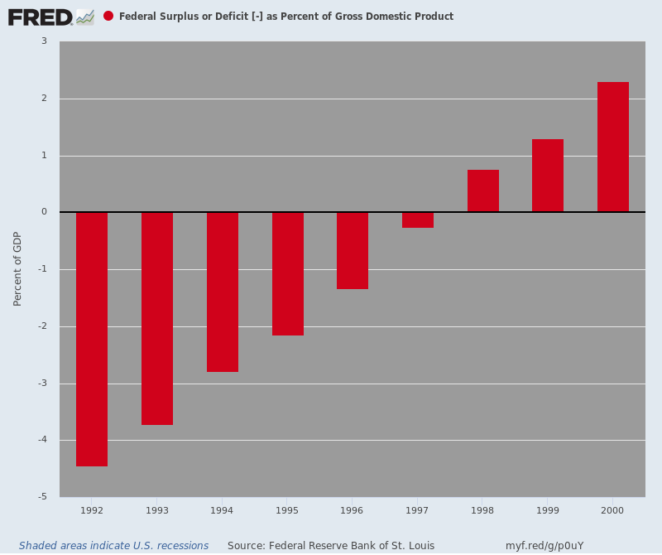
By contrast, during the last 12 months the net Federal debt has increased by $1.15 trillion and the Fed drained another $350 billion from the bond pits under QT. So what we've had is a $1.5 trillion cash drain from the bond pits---a figure which represents about 7.5% of GDP for the last 12 months running.
The above figures also reflect the loss of revenue from the Trumpite/GOP tax cuts, which amount to about $400 billion during the Donald's first four budget alone, and more than $1.8 trillion over the 10-tear horizon.
Indeed, legislation passed and signed on the Donald's watch to date will add $4.1 trillion to the massive structural deficits that were left on the White House doorstep by his predecessors.
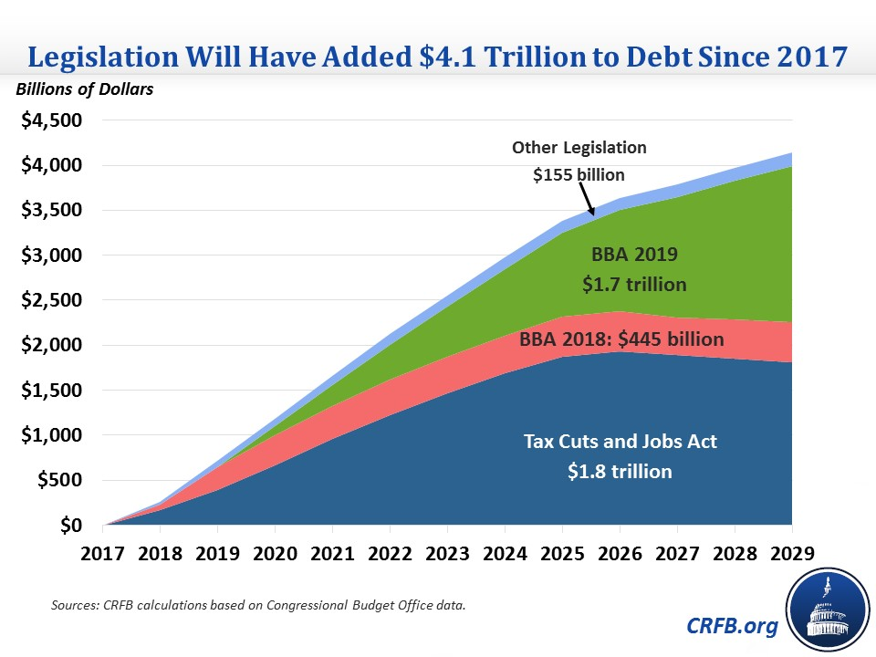
But here's the thing. The structural deficit has now become so enormous that it has taken on a life of its own.
The tsunami of Baby Boom retirements in the 2020s will balloon the Welfare State budget by trillions. At the same time, the Warfare State budget at $1.1 trillion per year all-in (counting veterans, international security and aid, homeland security, nuclear energy and DOD) has now created its own massive military/industrial/surveillance/ NGO/think tank lobbies, thereby becoming virtually self-perpetuating.
That means, in turn, the interest burden will soar---even under a scenario of low Treasury yields that never become fully normalized. CBO's latest projections, in fact, show that Federal debt service costs will triple by the end of the 2020s and cross the $1 trillion per year mark.
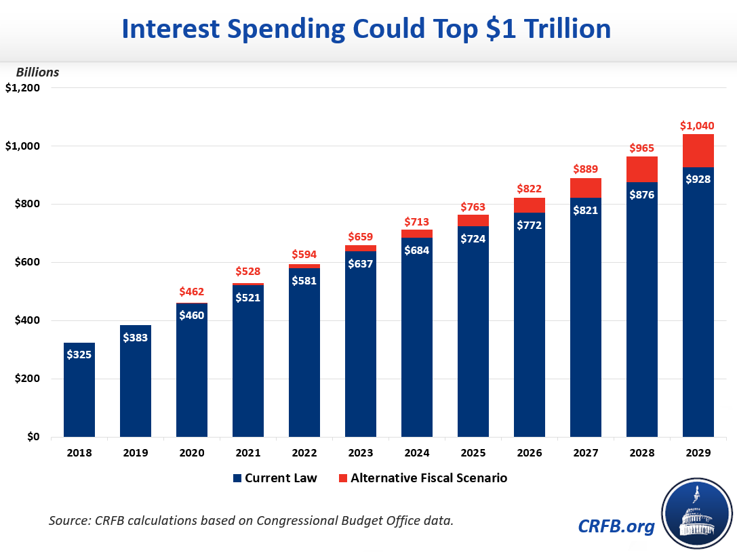
In short, the public debt is heading for the stratosphere and will hit 150% of GDP in the 2040s if there is never another recession, and during the early 2030s if the US economic once again succumbs to a cyclical contraction---as it has nearly two dozen times over the past two centuries.
Is there any wonder, therefore, that the Fed is already confronting money and debt markets which do not wish to obey its interest rate commands?
After all, it's not repo madness at all. [Well, it is kinda because that's what has been leading to larger and larger income inequality. –FNC]
It's the debt, stupid!
